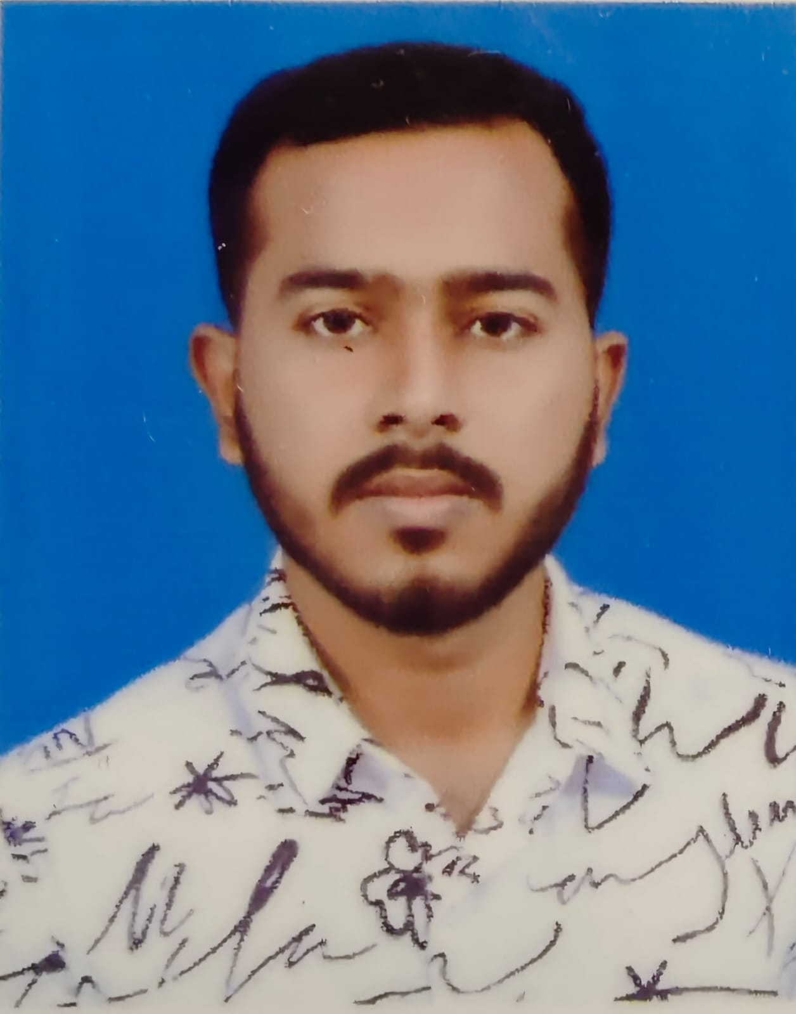
Tushar Sarkar

Falakata, Alipurduar  PIN: 735211  8918709763  tsarkar431@gmail.com | Summary  Computer science student with a passion for coding. Seeking a position to leverage my technical skills and contribute to innovative software development projects. Eager to learn from experienced professionals and continuously improve my skills.
Education  - Master of Computer Applications (8.08 CGPA)  Institute of Engineering & Management 2024  - Bachelor of Computer Applications (9.51 CGPA)  North Bengal University 2022  - Higher Secondary (61.6%)  Falakata High School 2018  - Secondary (71.42%)  Falakata High School 2016  Experience  - 2 years of hands on experience in Python with Deep Learning ( A Study On Conditional Generative Adversarial Network using Retinal Fundus Images )  - Image Processing (OpenCV) | Languages  - Bengali (Read, Write, Speak)  - Hindi (Read, Speak)  - English (Read, Write, Speak)  Skills  - Java, Python, C, C++  - HTML, CSS, JavaScript  - Linux

